Name: JIan Wang Course: Computational Finance Fsuid: Jw09r

- Executive Summary
In this problem, I calculated the value of a European put by solving the Black-Scholes equation with a second order finite difference method.
I used K=$10, r=$0.05/yr, =0.20/yr, T=0.5/yr with accuracy to nearest penny, the results of the value of put option are as follows with the S belongs to [0,20]

S | V | S | V
S=1 | 8.75 | S=11 | 0.16
S=2 | 7.75 | S=12 | 0.05
S=3 | 6.75 | S=13 | 0.01
S=4 | 5.75 | S=14 | 0.00
S=5 | 4.75 | S=15 | 0.00
S=6 | 3.75 | S=16 | 0.00
S=7 | 2.76 | S=17 | 0.00
S=8 | 1.8 | S=18 | 0.00
S=9 | 0.99 | S=19 | 0.00
S=10 | 0.44 | s=20 | 0.00
The result is displayed in the nearest cent.
Besides, if we choose S=8:
Then according to the above table
V=$1.80 (accurate to the nearest penny).
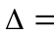=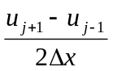=-0.908
I also check the model with a know solution PDE program, the result shows that the model is feasible.

- Statement of Problem
Compute the value of the European put by solving the Black-Scholes equation with a second order finite difference method. I used the Crank-Nicolson method to solve this partial differential equation. Besides, I also calculate the sensitivity of the value of the option to the interest rate. Finally, I used a known function to test the accuracy of my model.

- Description of The Mathematics
Firstly, we already know the initial-boundary-value (IBVP) for the European put is
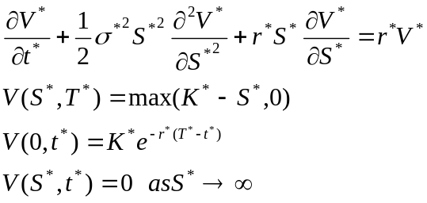
We scaled this by letting:
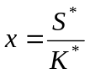, 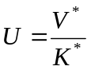, 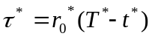, 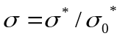,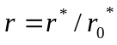, 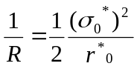
then we have equations:
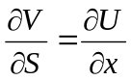, 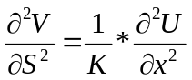, 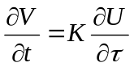
So the scaled IBVP is:
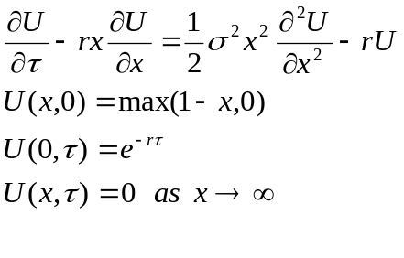

Secondly,
we used Crank-Nicolson approximation to find the numerical solution to this PDE problem. The formula is as follows:
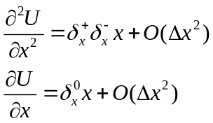
Then
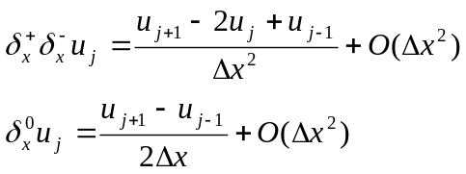
Now we use Trapezoidal Rule to integrate through from 0 to T, we get following equations:
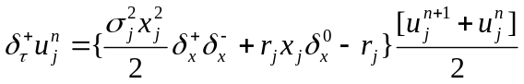
Where

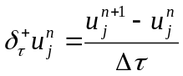
So we can represent the whole problem as:

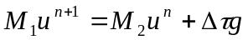
Where: 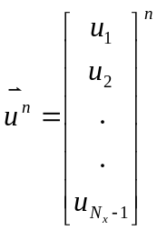, 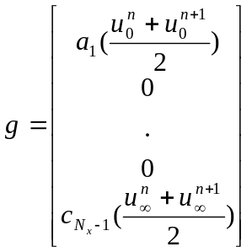
And:
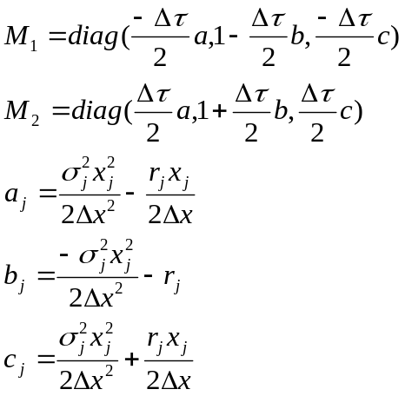

Thirdly, form the following formula, we can get the error.

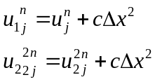

Then the error is as follows:
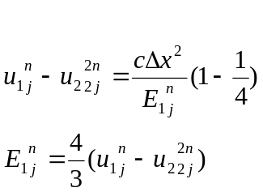

Finally,
I used a known solution PDE problem to check the accuracy of the model. If we add a forcing term 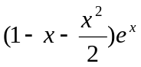to the right of the initial problem, and let 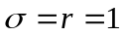. Then the exact solution of the following problem is 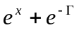
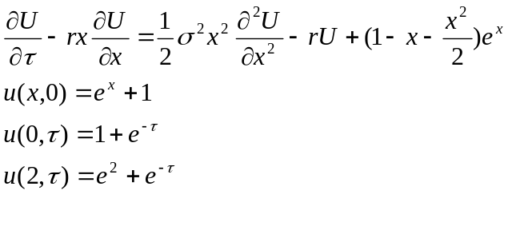
- Description of the Algorithm
Get 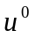form the initial function of S
Input 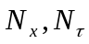
For n=0 To 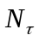-1
Compute 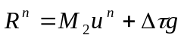
Solve 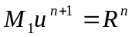 for 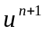
Next n

- Results
The Value of European put calculated by C-N procedure for K=$10, r=$0.05/yr, =0.20/yr, T=0.5/yr with accuracy to nearest penny is as follows:

S | V | S | V
S=1 | 8.75 | S=11 | 0.16
S=2 | 7.75 | S=12 | 0.05
S=3 | 6.75 | S=13 | 0.01
S=4 | 5.75 | S=14 | 0.00
S=5 | 4.75 | S=15 | 0.00
S=6 | 3.75 | S=16 | 0.00
S=7 | 2.76 | S=17 | 0.00
S=8 | 1.8 | S=18 | 0.00
S=9 | 0.99 | S=19 | 0.00
S=10 | 0.44 | s=20 | 0.00

By running the procedure two times with 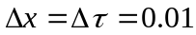 and 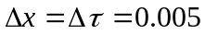, we can get the following output in which the absolute error was calculated by the equation 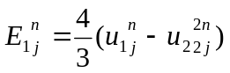. The results are as follows:

Stock Price | Option value | Abs Error | Rel Error
1 | 8.7531 | 5.07974E-09 | 5.80336E-10
2 | 7.7531 | 5.07974E-09 | 6.55188E-10
3 | 6.7531 | 5.07972E-09 | 7.52206E-10
4 | 5.7531 | 5.03924E-09 | 8.75917E-10
5 | 4.7531 | -6.68012E-08 | -1.40542E-08
6 | 3.75319 | -5.21828E-06 | -1.39036E-06
7 | 2.75687 | 3.74006E-05 | -1.35663E-05
8 | 1.79871 | 8.50182E-06 | 4.72663E-06
9 | 0.987804 | 0.000237598 | 0.000240531
10 | 0.441628 | 0.000344371 | 0.000779777
11 | 0.160418 | 0.000219242 | 0.00136669
12 | 0.0482722 | 7.21586E-05 | 0.00149483
13 | 0.0123743 | -6.74375E-06 | 5.44981E-05
14 | 0.00278088 | -6.03358E-06 | -0.00216966
15 | 0.00056237 | -4.1625E-06 | -0.0074017
16 | 0.00010467 | -1.67051E-06 | -0.0159594
17 | 1.8275E-05 | -5.23964E-07 | -0.0286705
18 | 3.0397E-06 | -1.40641E-07 | -0.0462674
19 | 4.7713E-07 | -3.24423E-08 | -0.0679954

2.
Since 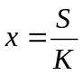, 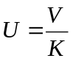, then 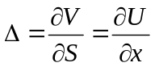.So choose S=8, V=$1.80. ==-0.908
3.
To test the sensitivity of the value of the option to the interest rate, I calculate the value of the greek 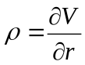
I choose the stock price as 8 and the following graph of is the  value where R change from 0 to 0.5. The following chart showed the result of the sensitivity.

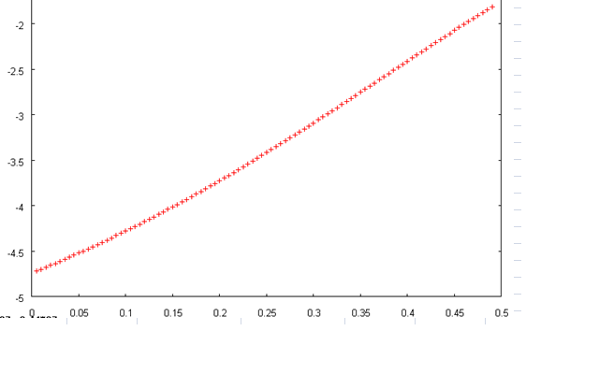

- Conclusions

I choose a known PDE problems to test the accuracy of the model.

The PDE formula is as follows:

And choose x from 0 to 2, from 0 to 1,, then the exact solution will be 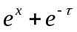. The theory tells us:
- The error =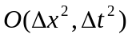.
In this case, since 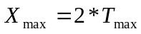. If we choose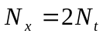, then 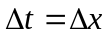 and the error calculated should be reduced at the level of 10⁻², when reduced at the level of 10⁻¹. The results are as follows:

Calculated value | Absolute Error | Delta t
2.59577 | 2.35E-03 | 0.1
2.59344 | 2.35E-05 | 0.01
2.59342 | 2.35E-07 | 0.001

The absolute error is the numerical solution calculated by C-N procedure minus the exact solution at the point x=0.8 and =1, which equals to 2.59342037.
Form the above table, we can see that the theory that when reduced to 1/10, the error reduced 1/100.

If we do the Crank-Nicholson procedure twice and choose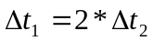. The error should satisfy the following equation, I have run the procedure twice by choosing 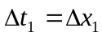=0.005 and 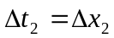=0.0025. The real error is calculated by calculated solution minus exact solution at x, and the estimated error is calculated by the equation, and these two columns match.

The following is the results:

The value of x | Real error | Estimated Error
0.1 | -1.41531E-07 | -1.41531E-07
0.2 | 7.8563E-07 | 7.8563E-07
0.3 | 1.80654E-06 | 1.80654E-06
0.4 | 2.80978E-06 | 2.80978E-06
0.5 | 3.74098E-06 | 3.74098E-06
0.6 | 4.5719E-06 | 4.5719E-06
0.7 | 5.28646E-06 | 5.28646E-06
0.8 | 5.8743E-06 | 5.8743E-06
0.9 | 6.32755E-06 | 6.32755E-06
1 | 6.63925E-06 | 6.63925E-06
1.1 | 6.80244E-06 | 6.80244E-06
1.2 | 6.80962E-06 | 6.80962E-06
1.3 | 6.65251E-06 | 6.65251E-06
1.4 | 6.32174E-06 | 6.32174E-06
1.5 | 5.80679E-06 | 5.80679E-06
1.6 | 5.09579E-06 | 5.09579E-06
1.7 | 4.17541E-06 | 4.17541E-06
1.8 | 3.03072E-06 | 3.03072E-06
1.9 | 1.64509E-06 | 1.64509E-06

We can see that the real error and the estimated error are just same, which shows that the formula and the results are right.

